Brigg Town Council

Community Emergency Plan

Owner: Brigg Town Council

Reviewed and adopted by the
Brigg Town Council

JUNE 2020

Section 1: activation

This plan will be activated when at least three members of the Brigg Town Council Community Emergency Team consider it necessary to take action in response to an incident, and when action cannot be taken effectively without triggering the arrangements outlined in this document.

If it is activated follow the key actions in Section 2.

Who Can Activate the Plan
Any three of the following people can activate this plan:

Clerk to Brigg Town Council or (in his/her absence) the Deputy / Assistant Clerk.

Town Mayor of Brigg or (in his/her absence) the Deputy Town Mayor of Brigg

The Brigg Flood Warden
The Brigg Snow Warden

Chairman, Brigg Town Council Planning & Environment Committee

The Clerk to the Council has the names and contact details for the current post holders.

If the decision is taken to activate this plan turn to
Section 2
and follow the key actions.

SECTION 2: KEY ACTIONS

Priorities will be emergency medical care,
shelter, food & water.

- Gather as much information about the situation as possible (ETHANE).

Exact location of
Type of incident
Hazards that are present or anticipated
Access routes for emergency responders
Number of people and/or properties involved (estimate)
Emergency services or other organisations already in attendance or required
(e.g. police fire, ambulance, utilities etc.)

IF THE SITUATION IS LIFE-THREATENING
DIAL 999 WITHOUT DELAY

- Make contact with the emergency services or North Lincolnshire Council if they are involved in the incident. Inform them of the contact number and location of the Community Emergency Team.

- Take control until the emergency services arrive

- Contact members of the Brigg Town Council, Community Emergency Plan Support Team

- Instruct everyone to follow the advice of the emergency services

- At all times be aware of your own safety and the safety of those around you.

- Consider whether you can work safely and effectively from your current location, or whether you need to move to an alternate location (see section 3)

- Arrange for local residents to be warned of any dangers

- Consider if it is necessary to open emergency accommodation? If so, ensure there is a power supply, heat and arrange for supplies of food and drink (if not readily available).

- Arrange for contact to be made with the vulnerable members of community identified in Section 5 as appropriate and arrange for advice / assistance to be offered.

- Arrange for the community resources / organisations identified in Section 4 to be made available as necessary.

- Tune into your local radio station (Radio Humberside and Radio Lincolnshire) and advise the community to do the same (the list of stations is included in their copy of the Household Emergency Plan)

- Maintain regular communications with the representatives of the responding organisations on the scene.

Section 3: community emergency team

Important: The information in the boxes marked with an asterisk will be recorded in the council’s emergency plan (Emergency Management Arrangements) and the North Lincolnshire Multi-agency Flood Compendium.

Community Emergency Team *
In the event of the plan being triggered, the following members of the community have agreed to form a Community Emergency Team to help to mitigate the effects on the local community:

Clerk to Brigg Town Council or (in his/her absence) the Deputy Clerk
Office Telephone 01652 659402
Staff Mobile – 07584315971

The Clerk to the Council will have the current contact numbers for the following additional members of the Activation Management Team.

Town Mayor of Brigg or (in his/her absence) the Deputy Town Mayor of Brigg
The Brigg Flood Warden
The Brigg Snow Warden
Chairman, Brigg Town Council Planning & Environment Committee

The Community Support Team, that will be called upon in the event that the plan is activated, will be made up of representatives of the following organisations/businesses

Members of Brigg Town Council

- St. John the Evangelist Church
- Brigg Senior Citizens Pop In
- Brigg Rotary Club
- Brigg District Lions Club
- Farmstar

Individual community volunteers
- JB Rural Services

Personal Contact numbers are not listed within this plan / but they are held by the Clerk to the Council.

LIST OF USEFUL CONTACTS

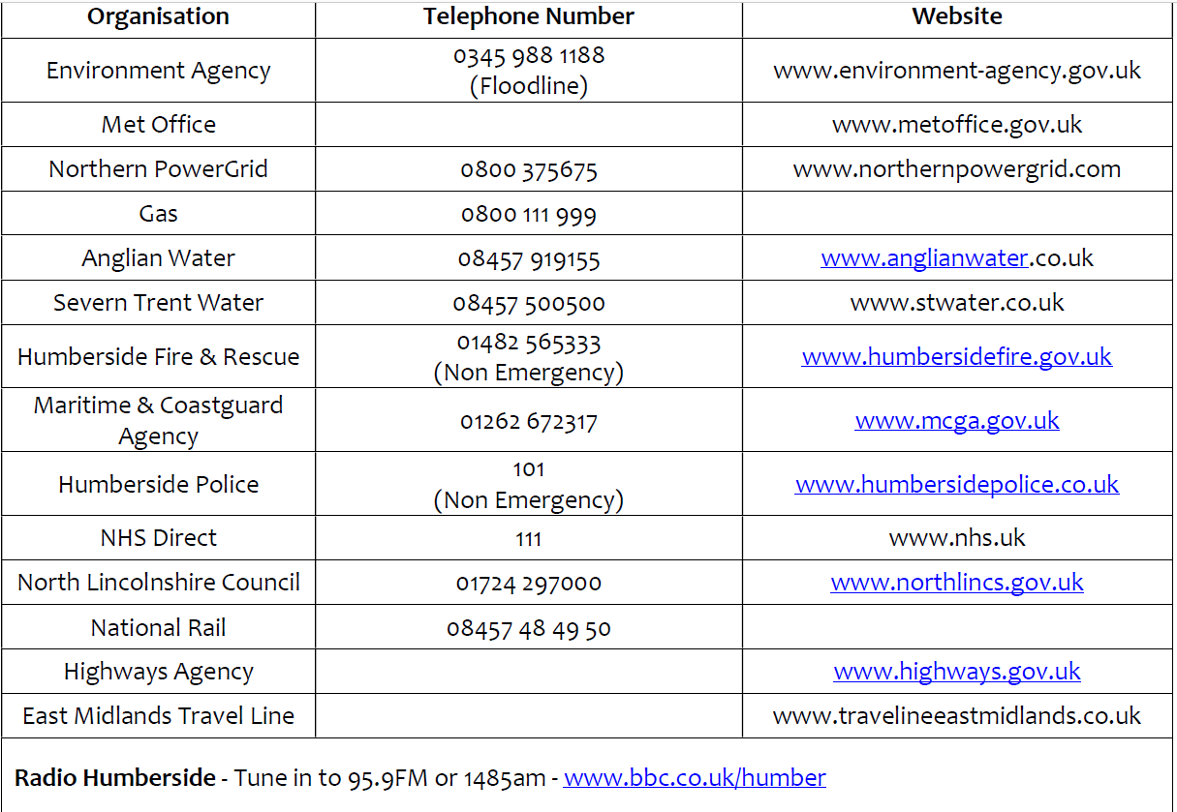

Community Incident Room *
If a Community Emergency Team is brought together, to discuss the community response, it has been agreed that they will meet at the following location:

The Angel S02, Market Place, Brigg, North Lincolnshire DN20 8LD.

Grid Reference SE 99946 07168

N.B. – For the purposes of satellite navigation the postcode for the Angel Suite Car Park is DN20 8LB

The Clerk to the Council will contact key holders for the Angel Suite, and will enable access to the building.

In the event that the Angel Suite can not be used, St. John the Evangelist Church Hall will be used. TA00065 07191

The Clerk to the Council will organise access.

Section 4: COMMUNITY RESOURCES

Community Emergency Box
A fireproof emergency box is located at The Town Council Office, the Angel, Market Place, Brigg, North Lincolnshire DN20 8LD.

GRID REFERENCE SE 99946 07168

N.B. – For the purposes of satellite navigation the postcode for the Angel Car Park is DN20 8LB

It contains:

- A copy of the Community Emergency Plan
- A copy of the electoral roll
- Ordinance Survey Map of Brigg and the immediate environs
- Laminated Street Plan – in A4 sections

Temporary Emergency Shelter
*In an emergency the following location has been designated as a potential
temporary emergency community shelter. N.B. This is in addition to any locations designated as such by North Lincolnshire Council.

The Angel Suite, Exchange Place, Brigg, North Lincolnshire DN20 8LD.
Grid Reference : SE 99946 07168

N.B. – For the purposes of satellite navigation the postcode for the Angel Suite Car Park is DN20 8LB

Key Holders:
North Lincolnshire Council - Telephone 01724 297000
Clerk, to Brigg Town Council – Telephone 07584 315971

Capacity of emergency community shelter: 200 closely seated

Cooking facilities: Full Kitchen

Car parking arrangements: Public car park - SE 99946 07168

Other Physical Resources within the Community
Sand bags will be supplied (as required) by North Lincolnshire Council.

A stock of salt is stored (on behalf of the Town Council) at the North Lincolnshire
Depot, Hewson House, Brigg. Grid reference SE 97487 03417

Suitable location(s) of hard standing for emergency vehicles:

Angel Car Park - Grid Reference TA 00004 07125
For the purposes of satellite navigation the postcode is DN20 8LB

Old Courts Road Car Park Grid Reference ? TA 00062 07380
For the purposes of satellite navigation the postcode is DN20 8JD

Market Place and Town Centre (Band Stand) North Lincolnshire Council would need to authorise. Grid Reference SE 99946 07215

For the purposes of satellite navigation the postcode is DN20 8JD

In the event of activation, the following resources may be useful.

Brigg & District Lions:
Have access to an emergency fund for the purchase of blankets / food etc

Glanford & Scunthorpe Canoe Club
Canoes – possibly manpower

Ancholme Rowing Club
Boats - possible manpower

Brigg Guides
camping equipment / tables / benches / cooking equipment

St. John Ambulance
First Aid Equipment and manpower

Farmstar – machinery
Peacock and Binnington - machinery
Turnbulls – machinery / sandbags / sand / snow shovels / buckets
Brians DIY – snow shovels / buckets
JB Rural Services – machinery and manpower

Environment Agency Floodline telephone number 0345 988 1188

skills within the Community

Knowledge of Vulnerable Residents / Listening and Supporting

Contact Telephone numbers are held on the Brigg Town Council Mobile telephone and are stored on icloud. Other relevant contact details are recorded on the Brigg Town Council web site:

www.briggmarkettown.co.uk

Brigg and District Carers Support Centre

Bridge Street GP Surgery

Riverside GP Surgery

Brigg Methodist Church

St. Mary’s R.C. Church

St. John the Evangelist Church

The Foundry Church

Brigg Senior Citizens

Brigg & District Breast Cancer Support Group

Brigg W.I. – Morning Group, Evening Group and Brigg Angels WI

Brigg Rotary Club

Brigg Gateway Club

First Aid

St. John Ambulance
Bridge Street Surgery
Riverside Surgery
Brigg L.I.V.E.S. First Responders

Catering Support / General Manpower

Brigg W.I. – Morning Group and Brigg Angels WI

Brigg Guides

Brigg Scouts

2222 Squadron Brigg A.T.C

Brigg Army Cadets

Section 5: vulnerable people

Vulnerable people within the Community
In order to avoid DATA protection issues, the names and addresses of vulnerable people are not identified within this plan.

The plan does, however, identify those organisations that will already have this information stored in their own database e.g. Carers Support Centre / Senior Citizens Forum./ GP Surgeries / Macmillan Cancer Relief / Brigg & District Breast Cancer Support Group

These organisations would be contacted to assist, should the need arise.

Section 6: plan publication

Plan Publication
Electronic copies of this plan have been e-mailed to:

North Lincolnshire Council
Brigg Neighbourhood Policing Team
Brigg Fire Station
East Midlands Ambulance Service
The Environment Agency

Paper copies of this plan are kept at: Brigg Town Council Office, The Angel, Market Place, Brigg, North Lincolnshire, DN20 8LD
A web version of the plan has been posted on www.briggmarkettown.co.uk

Section 7: plan maintenance

Plan Maintenance Roles and Responsibilities

The owner of the plan should make sure that all the people who are involved in the plan aware of their role, and know that that they might be contacted during an emergency.

This plan will be exercised by Brigg Town Council as part of any wider exercise organised by North Lincolnshire Council and/or the Emergency Services.

The Clerk to Brigg Town Council will have responsibility for arranging the Brigg Town Council exercise.

An exercise guide and some potential scenarios are available at www.heps.gov.uk, or by calling 01482 393056.

The plan will be reviewed at least annually. During the review every section of the plan will be checked for accuracy (telephone numbers, resource lists etc).

Brigg Town Council will have responsibility for reviewing the emergency plan.

Any updates to the plan, or lessons that have been learned from exercises, should be approved by the Brigg Town Council before the plan is changed.

Section 8: the multi agency response to a major incident

Response to a typical major incident

Normally the police co-ordinate the response to major incidents. When the incident moves into the recovery phase the lead co-ordination role may pass from the police to one of the other responding organisations. It could be the council, the Environment Agency or the primary care trust.

The emergency response is built from the ground up and additional layers of management are added according to the scale of the incident.

Operational (Bronze) co-ordination.

The operational area is where the ‘hands-on’ work is done. Responding organisations work side by side at the scene.

An “inner cordon” for essential workers is set up around the immediate vicinity of the incident.

The police establish an outer cordon at a safe distance around the inner cordon to provide a safe area for all responders.

Tactical (Silver) co-ordination

Large emergencies are greedy on resources. To ‘do the most for the most’ a level of management is needed to decide on the best tactics to employ. To achieve that a multi-agency tactical (Silver) level of management is set up. All responding organisations normally send a member of staff to attend the tactical level group. It is usually based in the police mobile ‘command’ vehicles within the outer cordon. But sometimes it is located away from the scene (e.g. a local police station) depending on the incident.

North Lincolnshire Council is not an emergency service. It does not have a mobile control. It co-ordinates its activities from one of its offices. It uses a trained Incident Manager to co-ordinate an Emergency Control Team made up of representatives from each involved service area.
The control team:
- helps to provide a co-ordinated council response.
- allows information to be shared more efficiently
- allows requests for services to be actioned more quickly.
- allows each service area to see how the incident affects them and
- decides how best to offer assistance.

The Incident Manager needs to know what’s happening at the multi-agency tactical (Silver) management group. So a Forward Liaison Officer goes to the scene to be the eyes and ears of the Incident Manager. All requests from the scene for council support are made through the Forward Liaison Officer who then speaks directly to the Incident Manager or Control Team.

The Forward Liaison Officer can:
- obtain regular position statements regarding the incident
- facilitate a swift response to a request for council services
- identify where council services can assist in the response to the incident
- assess the impact of the incident on the council and the community

The Incident Manager has access to a list of all the Parish and Town Council’s that have prepared emergency plans, along with their contact details, and will make contact as soon as initial actions have been completed.

Strategic (Gold) co-ordination

Each organisation may decide to convene its own top-level strategic group.

North Lincolnshire Council has a Strategic Emergency Management Team (SEMT). Elected members provide advice to the SEMT.

To ensure there is a co-ordinated strategy across all responding organisations in the Humber area, a Strategic Co-ordination Group (SCG) is established, normally hosted and chaired by the police. They meet at a location completely detached from the scene with suitable communications and meeting facilities. For the Humber area this is normally be at Police Headquarters at Queens Gardens in Hull.

The SCG determine the multi-agency strategic issues including the management of the aftermath of the incident and the return to normality.

North Lincolnshire Council send a member of the executive to the SCG.

Regional co-ordination

If an incident has implications for one or more Government Office regions, a Regional Civil Contingencies Committee (RCCC) may be established. They liaise with other regions and report directly to the Government.

An member of the Humber SCG would represent the Humber area on this committee.

National co-ordination

Some incidents that require national resources and co-ordination trigger central government involvement. National support is co-ordinated by the Cabinet Office Briefing Room (COBR).

Response to a Major Emergency
This section contains public information for various incident types that your Community Emergency Team may be able to help cascade to members of the community. Emergency responders may also issue advice through their website, emails to you and through radio announcements.

Heavy Winds
- Secure loose objects such as ladders and garden furniture.
- Close and securely fasten doors and windows, including garages.
- Park vehicles in a garage or in a place clear of buildings, trees and fences.
- Stay indoors if possible.
- If you need to go outside, do not walk or shelter close to buildings or trees.
- Don’t carry out repairs whilst the storm is in progress.
- Do not drive unless your journey is essential and avoid exposed routes.
- Do not touch electric/telephone cables which may have to be blown down.

Heat Wave
- Try and plan your day to stay out of the heat, keep rooms shaded and, where possible use a
- fan.
- If you must go out, stay in the shade, wear a hat and loose fitting clothing.
- Drink plenty of fluids.
- Don’t leave animals unattended in cars in warm weather.
- Seek medical help if you suffer from heat exhaustion or heat stroke. Remain somewhere cool,
- sponge yourself with cold water and drink plenty of fluids.

Snow and Ice
- Carry an emergency car kit - mobile phone, car charger, first aid kit, warm waterproof clothes,
- blanket, food, water, torch (with spare batteries).
- Inform a friend or family member of your intended travel arrangements and expected arrival
- time.
- Wear a hat.
- Watch out for signs of hypothermia - uncontrollable shivering, slow or slurred speech,
- drowsiness and memory lapse.
- Don’t drive unless you absolutely need to.

Flooding
- Listen to your local radio and TV weather forecasts for advice from the emergency services.
- Move your car to higher ground.
- Empty furniture drawers and cupboards. Place the contents and any furniture you can
- upstairs.
- Fasten plastic bags round the legs of wooden furniture to help minimise absorption of water.
- Turn off mains gas and electricity.
- Put plugs in sinks and weight them down to prevent backflow from the drains. Weigh down
- the loo seat too.
- Bring caged outdoor pets inside, move all pets with food, water, bedding and litter trays
- upstairs.
- Make sure any valuable or sentimental items and important documents are safe.

REMEMBER - We do not encourage communities to enter floodwater. Moving floodwater can be
extremely powerful and easily knock people off their feet. There could also be unseen obstructions that could be hard or sharp, potentially causing serious injury, and there are risks of entanglement.

Flooding can dislodge manhole covers that people could fall into and become trapped.

Remember, floodwater will probably also contain raw sewage. If you need to walk through floodwater consider using a pole (brush handle) to test the ground in front of you
Always wash your hands/arms/legs with hot water and soap if you do come into contact with
floodwater.

DO NOT allow children to play in floodwater.

Put any flood protection in place.

Encourage members of the community to check on their neighbours, especially if they are elderly or live on their own.

If people are advised to evacuate their homes, try and remind people of the steps they should take:
- Grab ‘Go bag’ and check contents.
- Turn off electricity, gas and water supplies and unplug appliances.
- Take their mobile phone and charger.
- Take some spare clothes.
- Take prescribed medication with them.
- Take cash and credit cards.
- Lock all doors and windows.

If they leave by car take bottled water, a duvet or blankets and tune to the local radio for emergency advice and instructions.

Section 10: Important contact DETAILS

In an emergency dial 999

Community Emergency team
Role: Clerk to Brigg Town Council
Work phone: 01652 659402 – Monday /Tuesday / Thursday only
Mobile phone: 07584 315 971
e.mail: enquiries@briggmarkettown.co.uk
Name: Cllr. Carl Sherwood
Role: Brigg Flood Warden
Home phone: 01652 655202
Mobile phone: 07789 991818
e.mail: cllr.carlsherwood@northlincs.gov.uk
Cllr. Robert Waltham
Role: Brigg Snow Warden
Mobile Phone: 07977 987903
e.mail: rob.waltham@northlincs.gov.uk
Other Community Leaders
Local MP
North Lincolnshire Ward Councillors
Ministers of the Church

Disclaimer
Whilst Brigg Town Council makes every attempt to ensure the accuracy and reliability of the information contained in this document it should not be relied upon as a substitute for formal advice from the originating bodies.

Brigg Town Council will not be responsible for any loss, however arising, from the use of, or reliance on this information.

Laws and regulations still apply during an emergency; so things like health and safety, speed restrictions, insurance, food hygiene and data protection must still be properly observed.

No one should carry out any tasks or activities that they are not properly
trained and qualified to do, and under no circumstances should anyone be
put at risk as a result of responding to the incident.

All those involved in this plan must follow the instructions and advice of the emergency services.

Clerk, Brigg Town Council

Flood risk summary for the area around:

MARKET PLACE, BRIGG, DN20 8LD

Detailed information can be found at https://flood-warning-information.service.gov.uk/long-term-flood-risk

Surface water
Medium risk
What this information means
This flood risk summary reports the highest risk from surface water within a 20m radius of this property.
Medium risk means that each year this area has a chance of flooding of between 1% and 3.3%.
This information is suitable for identifying:
- which parts of counties or towns are at risk, or have the most risk
- the approximate extent and depth of flooding
It is unlikely to be reliable for a local area and very unlikely to be reliable for identifying individual properties at risk.

Surface water flooding, sometimes known as flash flooding:
- happens when heavy rain cannot drain away
- is difficult to predict as it depends on rainfall volume and location
- can happen up hills and away from rivers and other bodies of water
- is more widespread in areas with harder surfaces like concrete
Lead local flood authorities (LLFA) are responsible for managing the flood risk from surface water and may hold more detailed information.
Your LLFA is North Lincolnshire council.
View a map of the risk of flooding from surface water below

Rivers and the sea
Very low risk
What this information means
This flood risk summary is not property specific.
Very low risk means that each year this area has a chance of flooding of less than 0.1%.
This service takes into account any flood defences.
The Environment Agency is responsible for managing the flood risk from rivers and the sea.
View a map of the risk of flooding from rivers and the sea below
