
The Town Mayor and Members
Brigg Town Council

To:

31st March 2014

YOU ARE HEREBY NOTIFIED AND SUMMONED to attend the MEETING of the PROPERTY & SERVICES COMMITTEE to be held in the Lounge of the ANGEL SUITE on Wednesday, 9th April 2014
at 7.45pm
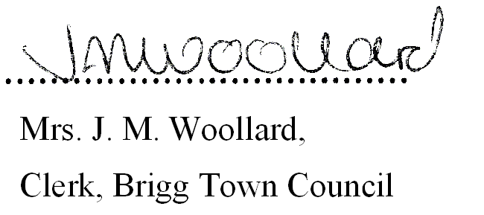

BUSINESS TO BE TRANSACTED

1. Notice Convening the meeting.

2. To Receive Apologies and Reasons for Absence

3. (a) To record declarations of interest by any member of the council in respect of the agenda items listed below. Members declaring interests should identify the agenda item and type of interest being declared.

(b) To note dispensations given to any member of the council in respect of the agenda items listed below.

4. To approve any general accounts for payment. (See Appendix 1)

5. ALLOTMENTS:

a) To Receive a report on any outstanding issues from the clerk:

b) Redcombe Lane site:
i) To Receive and Consider the site visit report and any observations from the Allotment Representative, and consider any questions from tenants.

ii) To Receive and Consider any reports from Countryside Pest Control.

c) Grammar School Road
- To Receive and Consider the site visit report and any observations from the
Allotment Representative, and consider any questions from tenants.

ii) To Receive and Consider any report from Countryside Pest Control.

Brigg Town Council
Property and Services Committee
Meeting – Wednesday 9th April 2014
Agenda/business to be transacted

6. ANGEL SUITE:
a) To receive the following financial reports and approve the Accounts Paid and for Payment.
(See Appendix 2). i) 28th February 2014 ii) 31st March 2014

b) To receive a general report from the Clerk.

c) To review the Fire Risk Assessment for the Angel Suite.

7. PROPOSED RE-DISTRIBUTION OF THE THREE B’s EQUIPMENT
a (Members are referred to the draft terms recommended by the clerk – details enclosed)

a)T a) To confirm the items of equipment to be retained by Brigg Town Council

b) To determine the terms for the re-distribution of the remaining equipment.

8. BRIGG RAILWAY STATION / PASSENGER RAIL SERVICE THROUGH BRIGG
To note and endorse the recommendations of the members delegated to consider the following:

- Hire of artificial floral displays to improve the aesthetic appearance of the station environment.

- Purchase and installation of a notice board to be sited in the vicinity of the junction of Station Road/Albert Street, for the purpose of publicising rail timetables and other relevant information to promote the use of the service.

9. REFURBISHMENT OF EXISTING STREET FURNITURE
- Public Information Boards
To consider the refurbishment of the existing tourist information boards, located at:
- Angel Car Park
- Old Courts Road Car Park
- Vicinity close to White Horse Public House
- Vicinity close to Sherwood Cycles

- Brigg UDC Toll Boards
To consider the refurbishment of the Toll Boards.

10. BRIGG IN BLOOM 2014
To consider the hire of hanging baskets with artificial flowers, for installation along the riverside between
the County Bridge and the Ancholme Way Bridge.

11. CHRISTMAS LIGHTS INSTALLATION 2014
To further consider improvements and associated costs in preparation for the 2014 Christmas Lights display, also to include requisite stress testing works.

12. FILM PRODUCTION
- In view of the confidential nature of the business about to be transacted under Agenda
Item 11b, it is advisable in the public interest that the press and public are excluded and they are instructed to withdraw.

- To Review the film created by young people during the final stages of the ThreeBs project
and finalise the arrangements for it to be shared with the young people and/or the public.

Brigg Town Council
Property and Services Committee
Meeting – Wednesday 9th April 2014
Agenda/business to be transacted

Appendix 1

General Accounts Paid

Angel Suite Accounts Paid

