
The Town Mayor and Members
Brigg Town Council

To:

5th December 2013

YOU ARE HEREBY NOTIFIED AND SUMMONED to attend the MEETING of the PROPERTY & SERVICES COMMITTEE to be held in the Lounge of the ANGEL SUITE on Wednesday 11th December 2013 at 7.30 pm
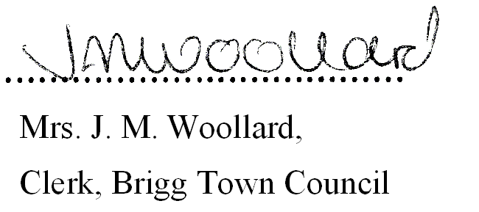

BUSINESS TO BE TRANSACTED

1. Notice Convening the meeting.
2. To Receive Apologies and Reasons for Absence

3. (a) To record declarations of interest by any member of the council in respect of the agenda items listed below. Members declaring interests should identify the agenda item and type of interest being declared.

(b) To note dispensations given to any member of the council in respect of the agenda items listed below.

4. a) To approve any general accounts for payment. (See Appendix 1)

b) To note and endorse the purchase of office equipment under the clerk’s delegated authority

5. COMMUNITY MEMORIAL GARDEN

a) To Receive a concluding report from the clerk

b) To approve the inclusion of the garden in the Town Council’s existing Service Level Agreement
for Brigg in Bloom; to include spring and summer planting, and grass cutting.

6. ANGEL SUITE:
a) To receive the following financial reports and approve the Accounts Paid and for Payment.
(See Appendix 2). i) 31st October 2013 ii) 30th November 2013

b) To receive a report from the Clerk on General Outstanding Issues.

c) To Receive a general report from the Angel Suite Manager

Brigg Town Council
Property and Services Committee
Meeting – Wednesday 11th December 2013
Agenda/business to be transacted

7. CHRISTMAS LIGHTS INSTALLATION 2013/14

a) To note that Full Council approved the increase expenditure incurred due to the necessity to re-test
failed anchor points.

a) To Receive a report from the clerk regarding the 2013 installation and consider any recommendations regarding the installation for 2014 and beyond.

8. THREE B’s – CONCLUSION OF THE PROJECT
a) To note and endorse the payment of the charges claimed in respect of damage to the van, following termination of the lease.
b) To discuss the future use of the property and equipment now stored in the Angel Suite.
9. ALLOTMENTS:

a) To Receive a report on any outstanding issues from the clerk:

b) Redcombe Lane site:

i) To Receive a report from the Clerk following unauthorised pruning, on the instructions of a tenant, of the cherry tree at the site.

ii) To Receive and Consider the site visit report and any observations from the Allotment Representative, and consider any questions from tenants.

iii) To receive a report from the clerk regarding
- the request to re-locate the gate.
- Maintenance of the Polar Trees within the site at the rear of the Allotments.

iv) To Receive and Consider any reports from Countryside Pest Control.

c) Grammar School Road

- To Receive and Consider the site visit report and any observations from the
Allotment Representative, and consider any questions from tenants.

ii) To Receive and Consider any report from Countryside Pest Control.

iii) To Receive and note a report from the clerk with regard to tenancy allocations.

d) i) In view of the confidential nature of the business about to be transacted under Agenda Item 9d(ii),
it is advisable in the public interest that the press and public are excluded and they are instructed to
withdraw.

ii) To Resolve a Private and Confidential matter following a report from the clerk

Brigg Town Council
Property and Services Committee
Meeting – Wednesday 11th December 2013
Agenda/business to be transacted

Appendix 1

General Accounts Paid

Brigg Town Council
Property and Services Committee
Meeting – Wednesday 11th December 2013
Agenda/business to be transacted
Appendix 2

Angel Suite Accounts Paid

