
The Town Mayor and Members
Brigg Town Council

To:

3rd February 2014

YOU ARE HEREBY NOTIFIED AND SUMMONED to attend the MEETING of the PROPERTY & SERVICES COMMITTEE to be held in the Lounge of the ANGEL SUITE on Wednesday, 12th February 2014 at 7.30 pm
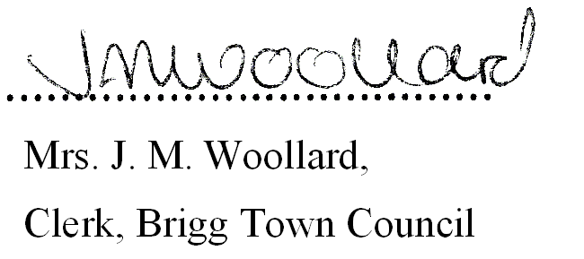

BUSINESS TO BE TRANSACTED

1. Notice Convening the meeting.
2. To Receive Apologies and Reasons for Absence

3. (a) To record declarations of interest by any member of the council in respect of the agenda items listed below. Members declaring interests should identify the agenda item and type of interest being declared.

(b) To note dispensations given to any member of the council in respect of the agenda items listed below.

4. To approve any general accounts for payment. (See Appendix 1)

5. COMMUNITY MEMORIAL GARDEN
a) To confirm the inclusion of the memorial garden in the Town Council’s existing Service Level Agreement
for Brigg in Bloom and note the cost.

b) To authorise the clerk to manage the changeover of posters displayed on the notice boards and associated costs.

6. ANGEL SUITE:
a) i) To receive the following financial reports and approve the Accounts Paid and for Payment.
(See Appendix 2). i) 31st December 2013 ii) 31st January 2014

ii) To Review the cumulative Financial Report - April 2013– January 2014(see enclosed)

b) To receive a report from the Clerk on General Outstanding Issues.

c) To Receive a general report from the Angel Suite Manager

7. CHRISTMAS LIGHTS INSTALLATION 2014/15

To consider recommendations from the working party appointed to review the installation of Christmas lights.

Brigg Town Council
Property and Services Committee
Meeting – Wednesday 12th February 2014
Agenda/business to be transacted

8. THREE B’s – EQUIPMENT
To discuss the future use of the property and equipment now stored in the Angel Suite. (Supporting information to follow.)

9. FILM CLUB
To receive a concluding report from the clerk regarding the film club project for young people commissioned through Cut Ltd; also to determine the arrangements for the film to be shown.

10. BRIGG RAILWAY STATION / PASSENGER RAIL SERVICE THROUGH BRIGG
(Members are referred to the written report received at the January 2014 Full Council meeting)

- To consider the purchase and installation of a notice board in the vicinity of the junction of Station Road/Albert Street, for the purpose of publicising rail timetables and other relevant information to promote the use of the service.

- To consider how the Town Council could assist with improvements to the station environment, possibly through minor, non-structural aesthetic improvements e.g. floral displays, litter control etc.

- To consider any other actions the Town Council can take to promote and encourage the use of the rail service through Brigg.

11. PUBLIC INFORMATION BOARDS
To consider the cost of refurbishing the existing information boards in the town.

12. ALLOTMENTS:

a) To Receive a report on any outstanding issues from the clerk:

b) Redcombe Lane site:
i) To Receive and Consider the site visit report and any observations from the Allotment Representative, and consider any questions from tenants.

ii) To Receive and Consider any reports from Countryside Pest Control.

c) Grammar School Road
- To Receive and Consider the site visit report and any observations from the
Allotment Representative, and consider any questions from tenants.

ii) To Receive and Consider any report from Countryside Pest Control.

d) i) In view of the confidential nature of the business about to be transacted under Agenda Item 9d(ii)(iii),
it is advisable in the public interest that the press and public are excluded and they are instructed to
withdraw.

- To receive a further report from the Clerk and resolve the Private and Confidential matter
discussed at the December meeting.

iii) To consider a confidential enquiry from North Lincolnshire Council.

Brigg Town Council
Property and Services Committee
Meeting – Wednesday 12th February 2014
Agenda/business to be transacted

Appendix 1

General Accounts Paid

Angel Suite Accounts Paid

