
The Town Mayor and Members
Brigg Town Council

To:
29 July 2026

YOU ARE HEREBY NOTIFIED AND SUMMONED to attend the MEETING of the PROPERTY & SERVICES COMMITTEE to be held in the Lounge of the ANGEL SUITE on Wednesday 9th October 2013 at 7.45pm
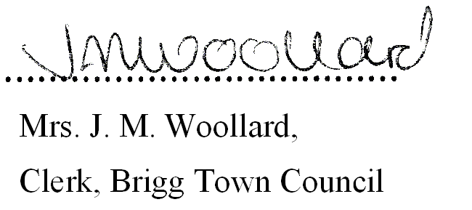

BUSINESS TO BE TRANSACTED

1. Notice Convening the meeting.

2. To Receive Apologies and Reasons for Absence

3. (a) To record declarations of interest by any member of the council in respect of the agenda items listed below. Members declaring interests should identify the agenda item and type of interest being declared.

(b) To note dispensations given to any member of the council in respect of the agenda items listed below.

4. TO APPROVE ANY GENERAL ACCOUNTS FOR PAYMENT. (See Appendix 1)

5. ANGEL SUITE:
a) i) To receive the following financial reports and approve the Accounts Paid and for Payment.
(See Appendix 2).

31st May 2013 30th June 2013 31st July 2013
31st August 2013 30th September 2013

ii) To Review the cumulative Financial Report for the 6 month period
April – September 2013(see enclosed)

b) To receive a report from the Clerk on General Outstanding Issues.

c) To receive a report from the clerk with regard to issues resolved under
delegated powers.

Brigg Town Council
Property and Services Committee
Meeting – Wednesday 9th October 2013
Agenda/business to be transacted

5./continued……

d) i) To Receive a general report from the Angel Suite Manager
ii) To receive and note the financial statement for the September 2013 Wedding Fair.

e) CCTV
To consider the cost of upgrading the system.

6. ALLOTMENTS:

a) To Receive a report on any outstanding issues from the clerk:

b) Redcombe Lane site:
i) To Receive and Consider the site visit report and any observations from the Allotment Representative, and consider any questions from tenants.

ii) To Receive and Consider any reports from Countryside Pest Control.

c) Grammar School Road
- To Receive and Consider the site visit report and any observations from the
Allotment Representative, and consider any questions from tenants.

ii) To Receive and note a report from the clerk with regard to tenancy allocations.

iii) To Receive and Consider any report from Countryside Pest Control.

7. WITH DUE REGARD FOR THE DECISION RESOLVED AT THE MEETING HELD ON WEDNESDAY 6TH MARCH 2013

a) To further consider the purchase and installation of additional salt bins in the vicinity of Ash Grove, and the additional cost to service the bin under the existing service level agreement with the North Lincolnshire Council Neighbourhood Services Team.

Proposed: Cllr. Mrs A. Eardley

b) To Receive and consider the offer of additional salt supplies, from North Lincolnshire Council.

8. REQUEST FOR ADDITIONAL DOG LITTER BINS
To consider the purchase and installation of additional dog litter bins, brought forward at the Annual Town Meeting, and also via e.mail. (details of locations and costs to be provided at the meeting)

9. COMMUNITY PROJECT TO CREATE A COMMUNITY MEMORIAL GARDEN
To Receive a progress report from the Clerk and consider for approval any expenditure required of the Town Council.

Brigg Town Council
Property and Services Committee
Meeting – Wednesday 9th October 2013
Agenda/business to be transacted

10. THREE B’s – CONCLUSION OF THE PROJECT
a) To note the report provided to Full Council by the Personnel Committee Chair, that the project has been brought to a close
- To receive and consider the concluding report from the lease hire company following the termination of the lease for the van.

- To note that a discussion will be undertaken at the next meeting with regard to the future use of property and equipment now stored in the Angel Suite.

11. CHRISTMAS LIGHTS INSTALLATION 2013/14
a) To award the contract for the installation of the Christmas Lights for 2013/14.

b) To receive and note the offers of financial assistance toward the cost of the Christmas Lights installation.

b) To note the recommendation that Stress Testing works should be undertaken annually and approve the cost of stress testing works required.

Brigg Town Council
Property and Services Committee
Meeting – Wednesday 9th October 2013
Agenda/business to be transacted

Appendix 1

General Accounts Paid

Brigg Town Council
Property and Services Committee
Meeting – Wednesday 9th October 2013
Agenda/business to be transacted
Appendix 2

Angel Suite Accounts Paid

