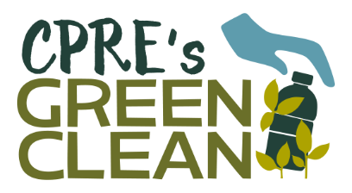 

**Please call David Rose 07762056445 for further information**

*For immediate release*

***Drinks containers deposit return scheme – reverse vending machine comes to Brigg***

In anticipation of the imminent deposit return system, the Campaign to Protect Rural England (CPRE) is organising a clean-up in Brigg on 4 September followed by a demonstration of a reverse vending machine in the Market Place.

It is planned to have the machine in place from 12.00 and members of the public will be able to see it in action by feeding empty cans and plastic and glass bottles into the machine. In return for every bottle and can they will get a voucher worth 10p.

On 28 March this year the Government announced: ‘a deposit return scheme to increase recycling rates and slash the amount of waste polluting our land and seas will be introduced subject to consultation later this year’. As CPRE had demanded for over 10 years, the scheme is set to include all single use drinks containers, whether plastic, glass or metal and will return a small cash sum to consumers who return their bottles and cans.

While we wait for the scheme to be put in place, England’s countryside remains awash with empty bottles and cans, causing serious harm to our natural environments and wildlife. So, throughout September CPRE is mobilising its network to encourage litter pickers to clear up the countryside as part of its nationwide ‘Green Clean’. The aim is to collect as much rubbish as possible and get it closer to the countryside we all want to see, before we have a deposit return system that will prevent it from becoming littered with cans and bottles ever again.

The [Campaign to Protect Rural England](https://www.cpre.org.uk/) (CPRE) has lobbied for a DRS for a decade and David Rose chair of the Northern Lincolnshire branch said: “I am delighted that we will finally see the many benefits a deposit system will bring to England, not least the absence of ugly drinks containers in our beautiful countryside.”

**Notes to Editor:**

1. You are cordially invited to attend the event – the first time a reverse vending machine has been demonstrated in our area. The machine should be in place by 11.45 and will positioned near the junction of Cary Lane and the Market Place in Brigg.
2. [Deposit return – the past becomes the future](http://www.cpre.org.uk/what-we-do/energy-and-waste/litter-and-fly-tipping/the-campaign)

For countries such as Norway and Germany that already have a system in place, littered bottles and cans are a rare sight, as the deposit system means that they have a monetary value and people either want to return them to collect their deposit or pick up those containers discarded by others to collect those deposits. Many other countries and provinces around the world have also found a deposit return system to be the best way to capture drinks containers, and you may recall a similar initiative for glass bottles in England some years back. Thanks to the monetary incentive, such schemes wield an unrivalled return rate of between 70-98.5%, with an associated reduction in other container litter of up to 80%.

1. Northern Lincolnshire Branch CPRE – Branch Chair David Rose 07762056445