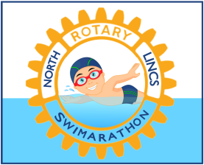
Corporate Sponsorship
North Lincolnshire Rotary Swimarathon. 4th March 2018
Application Form

The Package includes:
- Lane Sponsorship for either the Morning or Afternoon Session
- Your Name / Logo Board at the head of the lane for the chosen session
- Your Name / Logo Board placed at the side of the pool for “other” session
- Mention on the official website with a link to the business’ own website
- Inclusion in publicity
- Inclusion in the pool side collective banner
- Mention in the swimmers joining pack
Full Business name of Corporate Sponsor: .........................................................................

Name to be displayed if different from above: ...................................................................

Web site address: ...........................................................................................

Principal Contact Name: ...................................................................................

Contact telephone numbers: ................................(land line) ....................................... (mobile)
email address………………………………………………………………………………….
Postal address: .................................................................................
...........................................................................................................
...........................................................................................................
Please send your completed application to Andrew Binns, Vending Enterprises, 2-4 Hoylake Road, Moorwell Rd. Ind. Estate, Scunthorpe. DN17 2AZ. Alternatively please scan the form and email it, together with a high resolution jpeg image of your logo to andrew@vendingenterprises.co.uk

Cheques should be made payable to “North Lincs. Rotary Swimarathon” please.

